Maternal cancer could be detected during prenatal testing

Published: Tuesday 14 July 2015 at 7am PST
A new study has revealed that genetic testing designed to detect chromosomal abnormalities in fetuses could also detect underlying conditions such as cancer in pregnant women.
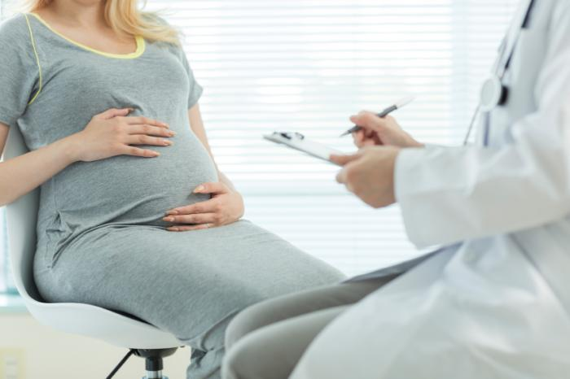
Noninvasive prenatal screening is a form of testing that can inform pregnant women if there is a chance their fetus has a chromosomal abnormality.
The study, published in JAMA, analyzed the cases of eight women who received noninvasive prenatal screening and had abnormal results.
Further analysis of the results demonstrated that the abnormal findings were not due to the fetuses having an abnormal karyotype (chromosomal characteristics of a cell) but were instead due to undiagnosed cancers in the mothers.
"This study provides one explanation for when noninvasive prenatal testing results are different from the fetal karyotype," says lead author Dr. Diana W. Bianchi, executive director of the Mother Infant Research Institute at Tufts Medical Center in Boston, MA.
"It highlights the need to perform a diagnostic procedure to determine true fetal karyotype whenever noninvasive prenatal testing suggests chromosomal abnormalities."
Noninvasive prenatal screening is a relatively new clinical process whereby pregnant women can find out if their fetuses might have chromosomal abnormalities - such as Down syndrome - by analyzing maternal and placental DNA found in the mother's plasma.
This screening can be offered as early as the tenth week of pregnancy and follow-up diagnostic testing is recommended to confirm any positive test results.
Cancer is not frequently detected in women during pregnancy - around 1 in 1,000 women are diagnosed with the disease at this time. Cancer that is detected during pregnancy occurs most often in the breast, cervix, colon and ovaries.
The eight cases analyzed in depth in the study came from a total of 125,426 samples from asymptomatic pregnant women who participated in noninvasive prenatal screening between 2012 and 2014.
A total of 3,757 cases were reported as positive for one or more abnormalities in the number of chromosomes 13, 18, 21, X or Y. The laboratory that conducted the noninvasive prenatal testing was later informed of 10 cases of cancer among the women.

'Women should be aware of this possibility'
For the study, 8 of these 10 cases were investigated further. The researchers discovered that each of these women had abnormal noninvasive prenatal screening results and that most of them had more than one chromosomal abnormality detected - a result considered to be unusual.
Cancer was diagnosed in these women either during pregnancy or after giving birth, at an average of 16 weeks following their initial noninvasive prenatal screening.
Based on the results of the study, the authors estimate there is a 20-44% risk of maternal cancer if multiple chromosomal abnormalities are detected. "However," they add, "until further studies are done to assess the clinical implications of discordant [noninvasive prenatal screening] and fetal karyotype results, it is not clear what, if any, follow-up clinical evaluation is appropriate."
"The take-home message is that women should be aware of this possibility when they seek testing," concludes Dr. Bianchi. "More research needs to be done to further study this occurrence to help guide physicians on how to counsel women and manage their follow-up care."
An accompanying editorial written by Dr. Roberto Romero and Dr. Maurice J. Mahoney states that these findings will become increasingly important as this form of screening becomes more widely used:
"Given that it is likely that [noninvasive prenatal screening] will increase in the coming years, an active dialogue among stakeholders (obstetricians, patients, laboratories, ethicists, policy makers, etc.) needs to take place to provide informed advice to potentially affected pregnant women and to guide the care of such patients."
Previously, Medical News Today reported on a study finding that women subjected to prenatal exposure to the pesticide DDTmore than 50 years ago may be at an increased risk of breast cancer than women exposed to lower levels.

